Sincennes, Alexandre

Colotouros, Nicholas

Lu, Rita

COMP-421, group 3

Project M3

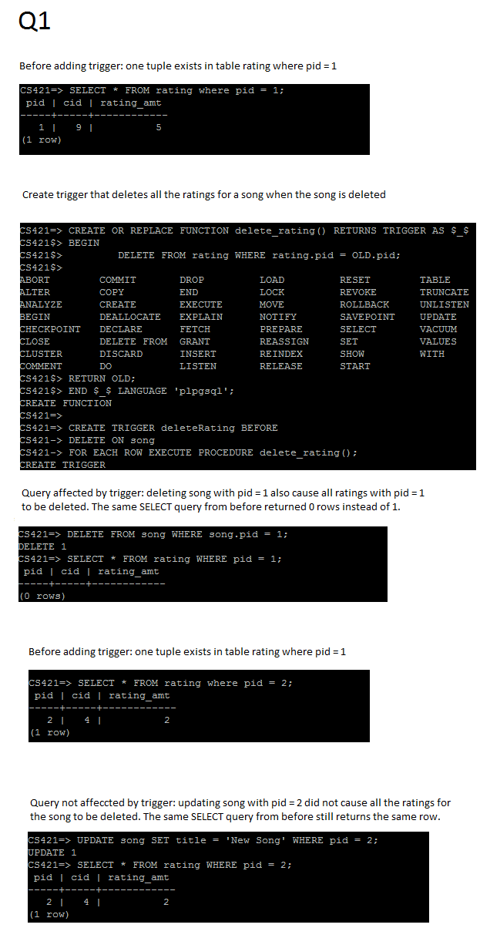

Q2

Before execution of the stored procedure:

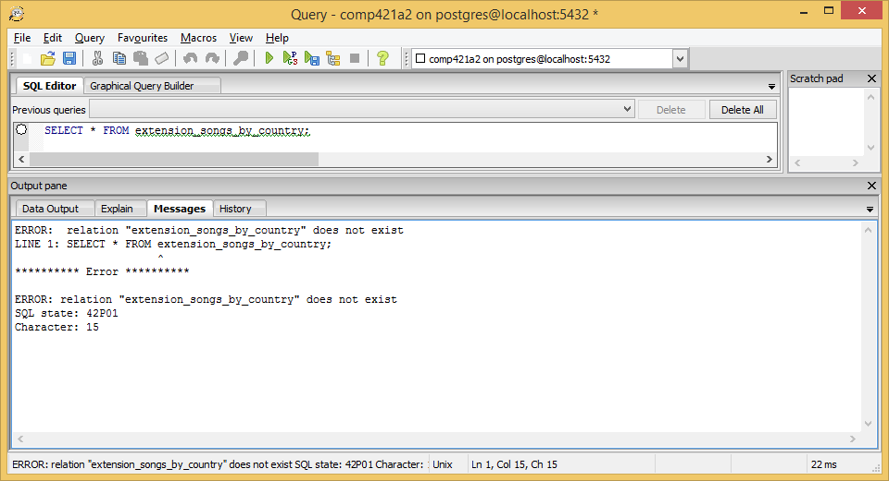

After execution:

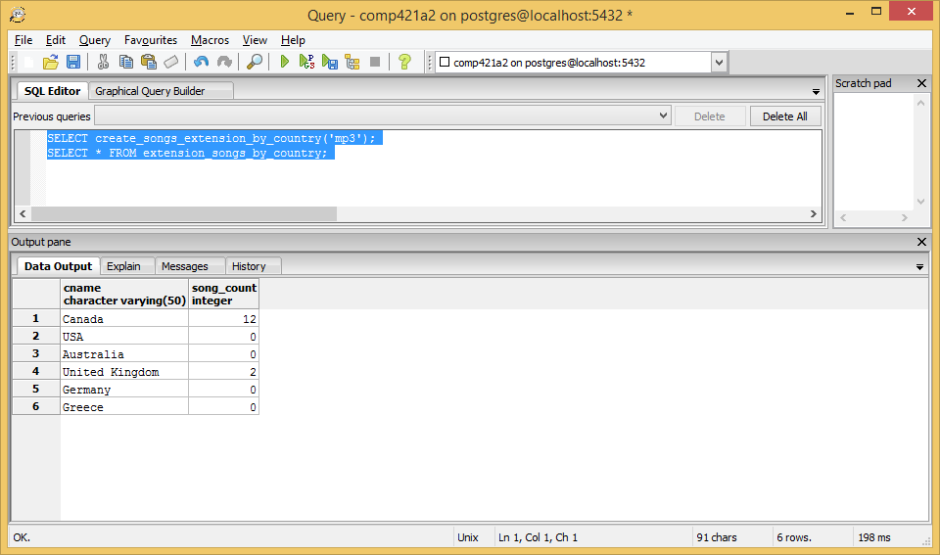

Q3

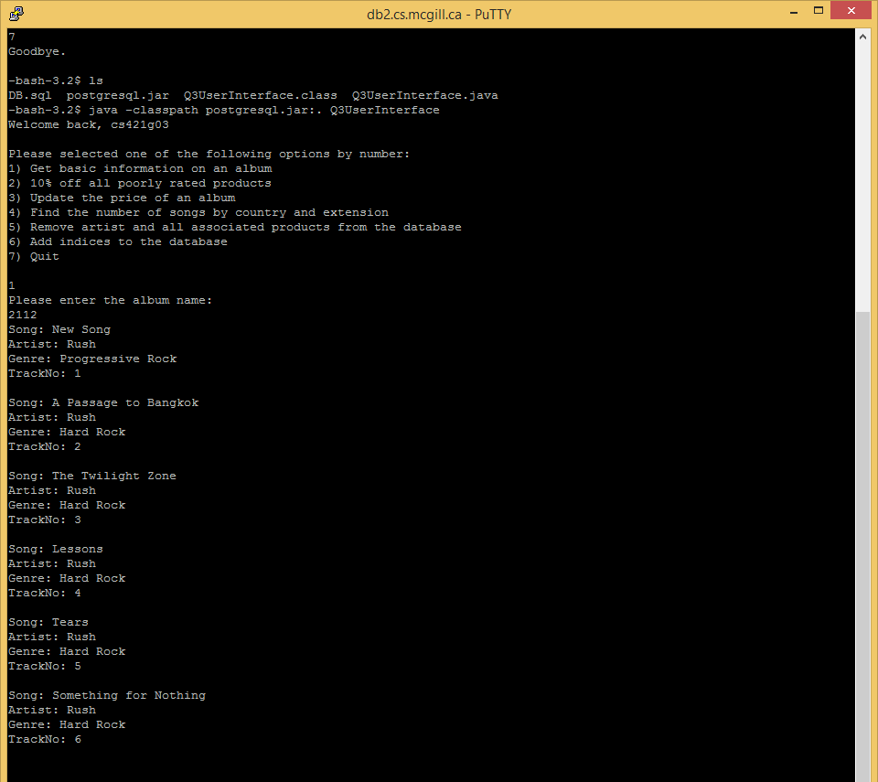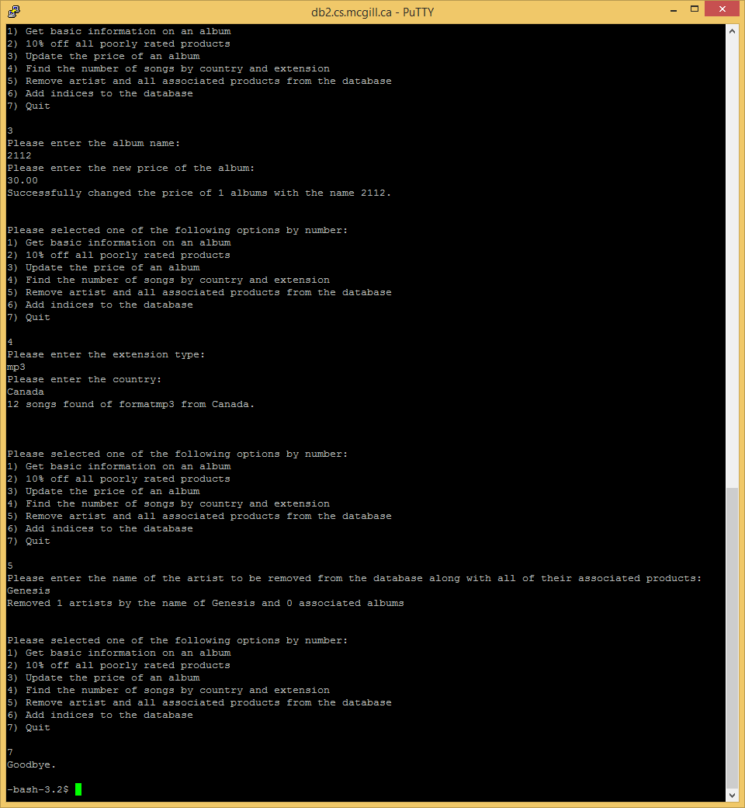

Last function of Q3, as well as Q4:

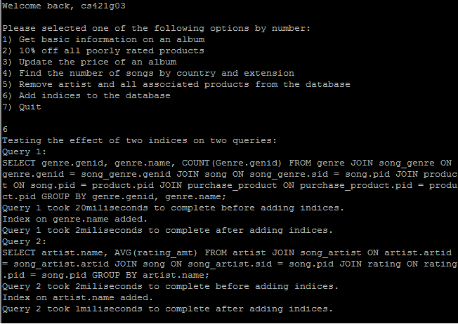

We go from 20 ms to 2 ms, and 2 ms to 1 ms, as shown above.